200125
version
Forestry Commission 22/08/2024 via Email
Summary:
Thank you for inviting the Forestry Commission to respond to the consultation on the Neighbourhood Plan, Unfortunately we do not have the resources to respond to individual plans but we have some key points to make relevant to all neighbourhood plans.
Full text:
Thank you for inviting the Forestry Commission to respond to the consultation on the Neighbourhood Plan, Unfortunately we do not have the resources to respond to individual plans but we have some key points to make relevant to all neighbourhood plans.
Forestry Commission and Neighbourhood Planning
Existing trees in your community
The Forestry Commission would like to encourage communities to review the trees and woodlands in their neighbourhood and consider whether they are sufficiently diverse in age and species to prove resilient in the face of tree pests and diseases or climate change. For example, if you have a high proportion of Ash, you are likely to see the majority suffering from Ash Dieback. Some communities are proactively planting different species straight away, to mitigate the effect of losing the Ash; you can find out more here. Alternatively, if you have a high proportion of Beech, you may find they suffer particularly from drought or flood stress as the climate becomes more extreme. There are resources available to help you get ideas for other species you can plant to diversify your tree stock and make it more resilient.
Ancient Woodland
If you have ancient woodland within or adjacent to your boundary it is important that it is considered within your plan. Ancient woodlands are irreplaceable, they have great value because they have a long history of woodland cover, with many features remaining undisturbed. This applies equally to Ancient Semi Natural Woodland (ASNW) and Plantations on Ancient Woodland Sites (PAWS). It is Government policy to refuse development that will result in the loss or deterioration of irreplaceable habitats including ancient woodland, unless “there are wholly exceptional reasons and a suitable compensation strategy exists” (National Planning Policy Framework paragraph 180).
The Forestry Commission has prepared joint Standing Advice for the treatment of Ancient Woodland
If you have ancient woodland within or adjacent to your boundary it is important that it is considered within your plan. Ancient woodlands are irreplaceable, they have great value because they have a long history of woodland cover, with many features remaining undisturbed. This applies equally to Ancient Semi Natural Woodland (ASNW) and Plantations on Ancient Woodland Sites (PAWS). It is Government policy to refuse development that will result in the loss or deterioration of irreplaceable habitats including ancient woodland, unless “there are wholly exceptional reasons and a suitable compensation strategy exists” (National Planning Policy Framework paragraph 180).
The Forestry Commission has prepared joint Standing Advice with Natural England on ancient woodland and veteran trees. This advice is a material consideration for planning decisions across England and can also be a useful starting point for policy considerations.
The Standing Advice explains the definition of ancient woodland, its importance, ways to identify it and the policies that relevant to it. It provides advice on how to protect ancient woodland when dealing with planning applications that may affect ancient woodland. It also considers ancient wood-pasture and veteran trees. It will provides links to Natural England’s Ancient Woodland Inventory and assessment guides as well as other tools to assist you in assessing potential impacts.
Deforestation
The overarching policy for the sustainable management of forests, woodland and trees in England is a presumption against deforestation.
Woodland Creation
The UK is committed in law to net zero emissions by 2050. Tree planting is recognised as contributing to efforts to tackle the biodiversity and climate emergencies we are currently facing. Neighbourhood plans are a useful mechanism for promoting tree planting close to people so that the cultural and health benefits of trees can be enjoyed alongside their broader environmental benefits. Any planting considered by the plan should require healthy resilient tree stock to minimise the risk of pests and diseases and maximise its climate change resilience, a robust management plan should also be put in place.
with Natural England on ancient woodland and veteran trees. This advice is a material consideration for planning decisions across England and can also be a useful starting point for policy considerations.
The Standing Advice explains the definition of ancient woodland, its importance, ways to identify it and the policies that relevant to it. It provides advice on how to protect ancient woodland when dealing with planning applications that may affect ancient woodland. It also considers ancient wood-pasture and veteran trees. It will provides links to Natural England’s Ancient Woodland Inventory and assessment guides as well as other tools to assist you in assessing potential impacts.
Deforestation
The overarching policy for the sustainable management of forests, woodland and trees in England is a presumption against deforestation.
Woodland Creation
The UK is committed in law to net zero emissions by 2050. Tree planting is recognised as contributing to efforts to tackle the biodiversity and climate emergencies we are currently facing. Neighbourhood plans are a useful mechanism for promoting tree planting close to people so that the cultural and health benefits of trees can be enjoyed alongside their broader environmental benefits. Any planting considered by the plan should require healthy resilient tree stock to minimise the risk of pests and diseases and maximise its climate change resilience, a robust management plan should also be put in place.
Attachments: None

200126
version
Sport England 22/08/2024 via Email
Summary:
Government planning policy, within the National Planning Policy Framework (NPPF), identifies how the planning system can play an important role in facilitating social interaction and creating healthy, inclusive communities. Encouraging communities to become more physically active through walking, cycling, informal recreation and formal sport plays an important part in this process. Providing enough sports facilities of the right quality and type in the right places is vital to achieving this aim. This means that positive planning for sport, protection from the unnecessary loss of sports facilities, along with an integrated approach to providing new housing and employment land with community facilities is important.
Therefore, it is essential that the neighbourhood plan reflects and complies with national planning policy for sport as set out in the NPPF with particular reference to Pars 102 and 103.
Full text:
Thank you for consulting Sport England on the above neighbourhood plan.
Government planning policy, within the National Planning Policy Framework (NPPF), identifies how the planning system can play an important role in facilitating social interaction and creating healthy, inclusive communities. Encouraging communities to become more physically active through walking, cycling, informal recreation and formal sport plays an important part in this process. Providing enough sports facilities of the right quality and type in the right places is vital to achieving this aim. This means that positive planning for sport, protection from the unnecessary loss of sports facilities, along with an integrated approach to providing new housing and employment land with community facilities is important.
Therefore, it is essential that the neighbourhood plan reflects and complies with national planning policy for sport as set out in the NPPF with particular reference to Pars 102 and 103. It is also important to be aware of Sport England’s statutory consultee role in protecting playing fields and the presumption against the loss of playing field land. Sport England’s playing fields policy is set out in our Playing Fields Policy and Guidance document. https://www.sportengland.org/how-we-can-help/facilities-and-planning/planning-for-sport#playing_fields_policy
Sport England provides guidance on developing planning policy for sport and further information can be found via the link below. Vital to the development and implementation of planning policy is the evidence base on which it is founded. https://www.sportengland.org/how-we-can-help/facilities-and-planning/planning-for-sport#planning_applications Sport England works with local authorities to ensure their Local Plan is underpinned by robust and up to date evidence. In line with Par 103 of the NPPF, this takes the form of assessments of need and strategies for indoor and outdoor sports facilities. A neighbourhood planning body should look to see if the relevant local authority has prepared a playing pitch strategy or other indoor/outdoor sports facility strategy. If it has then this could provide useful evidence for the neighbourhood plan and save the neighbourhood planning body time and resources gathering their own evidence. It is important that a neighbourhood plan reflects the recommendations and actions set out in any such strategies, including those which may specifically relate to the neighbourhood area, and that any local investment opportunities, such as the Community Infrastructure Levy, are utilised to support their delivery.
Where such evidence does not already exist then relevant planning policies in a neighbourhood plan should be based on a proportionate assessment of the need for sporting provision in its area. Developed in consultation with the local sporting and wider community any assessment should be used to provide key recommendations and deliverable actions. These should set out what provision is required to ensure the current and future needs of the community for sport can be met and, in turn, be able to support the development and implementation of planning policies. Sport England’s guidance on assessing needs may help with such work. http://www.sportengland.org/planningtoolsandguidance
If new or improved sports facilities are proposed Sport England recommend you ensure they are fit for purpose and designed in accordance with our design guidance notes. http://www.sportengland.org/facilities-planning/tools-guidance/design-and-cost-guidance/
Any new housing developments will generate additional demand for sport. If existing sports facilities do not have the capacity to absorb the additional demand, then planning policies should look to ensure that new sports facilities, or improvements to existing sports facilities, are secured and delivered. Proposed actions to meet the demand should accord with any approved local plan or neighbourhood plan policy for social infrastructure, along with priorities resulting from any assessment of need, or set out in any playing pitch or other indoor and/or outdoor sports facility strategy that the local authority has in place.
In line with the Government’s NPPF (including Section 8) and its Planning Practice Guidance (Health and wellbeing section), links below, consideration should also be given to how any new development, especially for new housing, will provide opportunities for people to lead healthy lifestyles and create healthy communities. Sport England’s Active Design guidance can be used to help with this when developing planning policies and developing or assessing individual proposals.
Active Design, which includes a model planning policy, provides ten principles to help ensure the design and layout of development encourages and promotes participation in sport and physical activity. The guidance, and its accompanying checklist, could also be used at the evidence gathering stage of developing a neighbourhood plan to help undertake an assessment of how the design and layout of the area currently enables people to lead active lifestyles and what could be improved.
NPPF Section 8: https://www.gov.uk/guidance/national-planning-policy-framework/8-promoting-healthy-communities
PPG Health and wellbeing section: https://www.gov.uk/guidance/health-and-wellbeing
Sport England’s Active Design Guidance: https://www.sportengland.org/activedesign
(Please note: this response relates to Sport England’s planning function only. It is not associated with our funding role or any grant application/award that may relate to the site.)
If you need any further advice, please do not hesitate to contact Sport England using the contact details below. Attachments: None

200127
version
Highways England 22/08/2024 via Email
Summary:
Thank you for consulting National Highways on the abovementioned Neighbourhood Plan.
National Highways is a strategic highway company under the provisions of the Infrastructure Act 2015 and is the highway authority, traffic authority and street authority for the Strategic Road Network (SRN).
It has been noted that once adopted, the Neighbourhood Plan will become a material consideration in the determination of planning applications. Where relevant, National Highways will be a statutory consultee on future planning applications within the area and will assess the impact on the SRN of a planning application accordingly.
Notwithstanding the above comments, we have reviewed the document and note that the details set out within the document are unlikely to have an severe impact on the operation of the trunk road and we offer No Comment.
Full text:
Thank you for consulting National Highways on the abovementioned Neighbourhood Plan.
National Highways is a strategic highway company under the provisions of the Infrastructure Act 2015 and is the highway authority, traffic authority and street authority for the Strategic Road Network (SRN).
It has been noted that once adopted, the Neighbourhood Plan will become a material consideration in the determination of planning applications. Where relevant, National Highways will be a statutory consultee on future planning applications within the area and will assess the impact on the SRN of a planning application accordingly.
Notwithstanding the above comments, we have reviewed the document and note that the details set out within the document are unlikely to have an severe impact on the operation of the trunk road and we offer No Comment. Attachments: None

200128 Comment
version
Cambridgeshire Constabulary
Petition: 2 petitioners
Date received: 22/08/2024 via Email
Summary:
Thank you for the opportunity to comment on the “Pampisford Neighbourhood Plan”.
Regarding Policy - we would like to refer you to the following and recommend these are included within the revised “The Pampisford” Neighbourhood Plan:
National Planning Policy Framework (NPPF) - Section 12 Paragraph 135 (f) which states: -
Planning policies and decisions should ensure that developments: create places that are safe, inclusive, and accessible and which promote health and well-being, with a high standard of amenity for existing and future users and where crime and disorder, and the fear of crime, do not undermine the quality of life or community cohesion and resilience.
In relation to the design and layout of new developments including homes, commercial space, schools, hospitals, and sheltered accommodation we make the following comment:
Security and Crime prevention measures should be considered at the earliest opportunity as an integral part of any initial design for a proposed development. It should incorporate the principles of ‘Secured by Design’ (SBD) and demonstrate how the development proposals address the following issues, to design out and reduce the incidence and fear of crime:
- Physical protection: Places that include necessary, well-designed security features.
- Access and movement: Places with well-defined routes, spaces and entrances that provide for convenient movementwithout compromising security.
- Safe routes: Creating safe routes that are as straight as possible, wide, well lit, without hiding places and well-maintained and overlooked for security and provide a sense of security for all users.
- Structure: Places that are structured so that different uses do not cause conflict.
- Lighting: Ensuring appropriate and non-obtrusive lighting levels are achieved.
- Private space: Creating a clear separation between public and private spaces, avoiding public routes next to backgardens.
- Surveillance: Places where all publicly accessible spaces are overlooked.
- Ownership: Places that promote a sense of ownership, respect, territorial responsibility, and community.
- Activity: Places where the level of human activity is appropriate to the location reduces the risk of crime and alwayscreates a sense of safety and territoriality.
- Management and maintenance: Places that are designed with management and maintenance in mind, to discouragecrime in the present and the future.
In practice this means that Secured by Design status for new developments can be achieved through careful design. Developers should, at an early stage, seek consultation and advice from the Police Designing out Crime Officers at Cambridgeshire Police Headquarters on designing out crime.
It is recommended that “Secured by Design” forms part of the conditions of any proposed planning application or redevelopment.
We would appreciate if the above could be taken into consideration.
Full text:
Thank you for the opportunity to comment on the “Pampisford Neighbourhood Plan”.
Regarding Policy - we would like to refer you to the following and recommend these are included within the revised “The Pampisford” Neighbourhood Plan:
National Planning Policy Framework (NPPF) - Section 12 Paragraph 135 (f) which states: -
Planning policies and decisions should ensure that developments: create places that are safe, inclusive, and accessible and which promote health and well-being, with a high standard of amenity for existing and future users and where crime and disorder, and the fear of crime, do not undermine the quality of life or community cohesion and resilience.
In relation to the design and layout of new developments including homes, commercial space, schools, hospitals, and sheltered accommodation we make the following comment:
Security and Crime prevention measures should be considered at the earliest opportunity as an integral part of any initial design for a proposed development. It should incorporate the principles of ‘Secured by Design’ (SBD) and demonstrate how the development proposals address the following issues, to design out and reduce the incidence and fear of crime:
- Physical protection: Places that include necessary, well-designed security features.
- Access and movement: Places with well-defined routes, spaces and entrances that provide for convenient movementwithout compromising security.
- Safe routes: Creating safe routes that are as straight as possible, wide, well lit, without hiding places and well-maintained and overlooked for security and provide a sense of security for all users.
- Structure: Places that are structured so that different uses do not cause conflict.
- Lighting: Ensuring appropriate and non-obtrusive lighting levels are achieved.
- Private space: Creating a clear separation between public and private spaces, avoiding public routes next to backgardens.
- Surveillance: Places where all publicly accessible spaces are overlooked.
- Ownership: Places that promote a sense of ownership, respect, territorial responsibility, and community.
- Activity: Places where the level of human activity is appropriate to the location reduces the risk of crime and alwayscreates a sense of safety and territoriality.
- Management and maintenance: Places that are designed with management and maintenance in mind, to discouragecrime in the present and the future.
In practice this means that Secured by Design status for new developments can be achieved through careful design. Developers should, at an early stage, seek consultation and advice from the Police Designing out Crime Officers at Cambridgeshire Police Headquarters on designing out crime.
It is recommended that “Secured by Design” forms part of the conditions of any proposed planning application or redevelopment.
We would appreciate if the above could be taken into consideration.
Attachments: None

200129 Support
version
Anglian Water Services Ltd
22/08/2024 via Email
Summary:
Anglian Water has previously submitted comments on the pre-submission version (Reg 14) of the Pampisford neighbourhood plan. We welcome the amendments in the submission version of the neighbourhood plan, following our comments and recommended changes.
I can confirm, Anglian Water has no further comments to make and wish the neighbourhood plan group every success in taking this forward.
Full text:
Anglian Water has previously submitted comments on the pre-submission version (Reg 14) of the Pampisford neighbourhood plan. We welcome the amendments in the submission version of the neighbourhood plan, following our comments and recommended changes.
I can confirm, Anglian Water has no further comments to make and wish the neighbourhood plan group every success in taking this forward.
I should be grateful if you could acknowledge receipt of this representation and keep me updated on further progress made on the neighbourhood plan.
Attachments: None

200132
version
Environment Agency 27/08/2024 via Email
Summary:
We aim to reduce flood risk, while protecting and enhancing the water environment.
Due to ongoing prioritization of our limited resource, we regret that at present, we are unable to review this consultation. We must focus on influencing plans where the environmental risks and opportunities are highest.
In focusing our engagement to those areas where the environmental risks are greatest, we note that based on the environmental constraints within the area, we have previously not submitted detailed comments relation to this Neighbourhood Plan. We therefore have no further detailed comments to make in relation to this plan.
Full text:
Thank you for consulting us on the Submission Publication for the Pampisford Neighbourhood Plan.
We aim to reduce flood risk, while protecting and enhancing the water environment.
Due to ongoing prioritization of our limited resource, we regret that at present, we are unable to review this consultation. We must focus on influencing plans where the environmental risks and opportunities are highest.
In focusing our engagement to those areas where the environmental risks are greatest, we note that based on the environmental constraints within the area, we have previously not submitted detailed comments relation to this Neighbourhood Plan. We therefore have no further detailed comments to make in relation to this plan. Attachments: None

200135
version
Historic England 06/09/2024 via Email
Summary:
"We welcome the production of this neighbourhood plan. Having reviewed the plan and relevant documentation we do not consider it necessary for Historic England to provide detailed comments at this time.
We would refer you if appropriate to any previous comments submitted at Regulation 14 stage, and for any further information to our detailed advice on successfully incorporating historic environment considerations into a neighbourhood plan, which can be found here: <https://historicengland.org.uk/advice/planning/plan-making/improveyour-neighbourhood/>
Full text:
Thank you for inviting Historic England to comment on the Regulation 16 Submission Draft of this Neighbourhood Plan.
We welcome the production of this neighbourhood plan. Having reviewed the plan and relevant documentation we do not consider it necessary for Historic England to provide detailed comments at this time.
We would refer you if appropriate to any previous comments submitted at Regulation 14 stage, and for any further information to our detailed advice on successfully incorporating historic environment considerations into a neighbourhood plan, which can be found here: <https://historicengland.org.uk/advice/planning/plan-making/improveyour-neighbourhood/>
Attachments: None

200138
version
Cambridge Past, Present and Future
24/09/2024 via Web
Summary:
Cambridge Past, Present & Future request that Policy PAM 12 and/or the supporting text make reference to to the Local Nature Recovery Strategy and Cambridge Nature Network.
Referencing the LNRS and the work of the CNN in Section 6.12 of the Neighbourhood Plan will help prioritise and direct biodiversity enhancements so that improvements within the parish are linked to wider biodiversity projects beyond the parish.
Full text:
Cambridge Past, Present & Future is Cambridge’s largest civic society. We are a charity run by local people who are passionate about where they live. We operate in the greater Cambridge area and working with our members, supporters and volunteers we are dedicated to protecting and enhancing the green setting of Cambridge for people and nature.
Cambridge Past, Present & Future request that Policy PAM 12 and/or the supporting text make reference to to the Local Nature Recovery Strategy and Cambridge Nature Network.
Cambridgeshire County Council will be producing a Local Nature Recovery Strategy (LNRS) which will set priorities for nature recovery. It will identify opportunities and priorities for recovering or enhancing biodiversity.
The LNRS will incorporate the work of the Cambridge Nature Network (CNN). Since 2018 CambridgePPF have been working with the Wildlife Trust, National Trust, local authorities and other organisations to identify a nature recovery network for the Cambridge area. The Cambridge Nature Network includes the best of the remaining habitats within 10km of the city and it identifies the best opportunities and locations for creating new habitats.
The River Cam and its tributaries are one of the nature priority areas in the network. The Neighbourhood Plan area lies between the River Cam Corridor to the west and River Granta corridor to the north-east.
The vision is that the Nature Network will be a mosaic of individual nature parks, nature reserves and farm habitats, linked together by nature-friendly farmland and wildlife-rich towns and villages. As well as being good for wildlife, it will be good for people.
Referencing the LNRS and the work of the CNN in Section 6.12 of the Neighbourhood Plan will help prioritise and direct biodiversity enhancements so that improvements within the parish are linked to wider biodiversity projects beyond the parish.
Suggested amendment
Cambridgeshire Local Nature Recovery Strategy and Cambridge Nature Network
Cambridgeshire County Council are producing a Local Nature Recovery Strategy (LNRS)
(https://cambridgeshirepeterborough-ca.gov.uk/what-we-deliver/environment/lnrs/) which will identify opportunities and priorities for recovering or enhancing biodiversity. The Cambridge Nature Network
(https://cambridgenaturenetwork.org/) identifies the best opportunities and locations for creating new habitats within a
10km ring around Cambridge. The River Cam and its tributaries are one of the nature priority areas. The Neighbourhood Plan area lies between the River Cam Corridor to the west and River Granta corridor to the north-east. Measures for delivering biodiversity enhancements should take into account other projects within the network and where possible create links between habitats.
I trust that you will take our comments into consideration.
Attachments: None

200139
version
Cheveley Park Farms Ltd
26/09/2024 via Web
Summary:
The draft neighbourhood plan fails to recognise major transport infrastructure that is planned within the neighbourhood plan area. Please see further details in attached letter and map.
Full text:
The draft neighbourhood plan fails to recognise major transport infrastructure that is planned within the neighbourhood plan area. Please see further details in attached letter and map.
Attachments:
Map showing land subject to planned transport infrastructure.png - https://cambridge.oc2.uk/a/3v6dj
Pampisford Reps Cheveley Park Farms Ltd_Redacted.pdf - https://cambridge.oc2.uk/a/3v6wb

Date: 26/09/2024

Dear Pampisford Neighbourhood Plan Team

COMMENTS ON DRAFT PAMPISFORD NEIGHBOURHOOD PLAN
On behalf of Cheveley Park Farms Ltd which controls some land (known as The Babraham Estate) within the Pampisford Neighbourhood Plan Area please find below our comments on the Neighbourhood Plan consultation.
Introduction
The attached plan extract (Map 5 on page 15 of the NP on planning constraints) shows land within the NP designated area which is subject to planned transport infrastructure, namely CSET. This Transport infrastructure project is planned within the land identified(in pink) and needs to be identified within the draft NP. The NP seeks to guide development within the plan period 2024 and 2041. The CSET proposal is planned to be constructed and operational within the next couple of years, well within the timescale and thus should be included within the NP document.
What is CSET?
Cambridge South East Transport: The proposed new public transport route and travel hub planned by the Greater Cambridge Partnership which would link the Cambridge Biomedical Campus via Great Shelford, Stapleford and Sawston to a new travel hub near the A11/A1307 with connections to the Babraham Research Campus and Granta Park.
Paragraph 3.26 of the Spring Budget Statement (red book) on 6 March 2024 states '£10.2 million is being invested to support the development of the Cambridge Biomedical Campus, Europe’s leading centre for medical research and health science. £7.2 million of this will unlock improvements to local transport connections for the Cambridge Biomedical Campus and the city, and £3 million is for Cambridge University NHS Trust to support plans for growth.'
On 7 March 2024 the Cambridgeshire & Peterborough Combined Authority and Cambridgeshire County Council issued the below joint statement in response to the Chancellor’s Spring Budget:
'Cambridgeshire remains one of the fastest growing areas in the UK. As a net contributor to the
Exchequer, if our region thrives, the whole country benefits. But we are not complacent, we support the Government’s ambition to solidify Cambridge as a global life sciences superpower. Transport is a limiting factor to our region’s growth. We welcome the Government providing £7.2 million for the next phase of developing the Cambridge South East Transport (CSET) programme, ensuring the Cambridge Biomedical Campus is connected and accessible as it grows.'



Bidwell House, Trumpington Road, Cambridge CB2 9LD
T: 01223 841841 E: info@bidwells.co.uk W: bidwells.co.uk
Bidwells is a trading name of Bidwells LLP, a limited liability partnership, registered in England and Wales with number OC344553.
Registered office: Bidwell House Trumpington Road Cambridge CB2 9LD. A list of members is available for inspection at the above address.
Please ensure you’re familiar with our Privacy Notice which is available here: bidwells.co.uk/privacy
property/client name etc. if applicable. double-click here and delete if not

Safeguarding land for public transport corridors and related land is a policy mechanism to ensure land which has been identified for development in the future is protected from conflicting development and applied in the production of development plans including NP’s.
The Draft NPPF
The new government’s Draft National Planning Policy Framework (NPPF July 2024) includes a number of relevant policy requirements in plan-making in this regard.
At paragraph 32 relating to preparing and reviewing plans it clearly states that 'The preparation and review of all policies should be underpinned by relevant and up-to-date evidence.'
Paragraph 106 states that 'Transport issues should be considered from the earliest stages of plan making.'
This continues in paragraph 107 which states that 'The planning system should actively manage patterns of growth in support of these objectives. Significant development should be focused on locations which are or can be made sustainable, through limiting the need to travel and offering a genuine choice of transport modes. This can help to reduce congestion and emissions, and improve air quality and public health. However, opportunities to maximise sustainable transport solutions will vary between urban and rural areas, and this should be taken into account in both plan-making and decision-making.' Paragraph 108 describes how 'Planning policies should:
c) identify and protect, where there is robust evidence, sites and routes which could be critical in developing infrastructure to widen transport choice
e) provide for any large scale transport facilities that need to be located in the area(including public transport projects) , and the infrastructure and wider development required to support their operation.'
Paragraph 153 states that 'Certain other forms of development are also not inappropriate in the Green Belt provided they preserve its openness and do not conflict with the purposes of including land within it. These are: c) local transport infrastructure which can demonstrate a requirement for a Green Belt location.'
Greater Cambridge Partnership Executive Board
The Greater Cambridge Partnership Executive Board Meeting on 2 October will consider CSET at Item 10. The report recommends the following actions are taken:
- Recommendations (key elements for CSET in bold)
6.1. The Executive Board is recommended to: a) Note the March 2024 Budget, and the funding allocation of £7.2m for promotion of the CSETS, together with the recent and ongoing discussions held with MHCLG; b) Note the updated Business Case for the scheme; c) Approve the commencement of the early delivery of the physical elements of the CSETS along Francis Crick Avenue, in order to support the opening of Cambridge South station; d) Approve the request to Cambridgeshire County Council for the submission of a Transport Works Act Order (TWAO), with the GCP working closely with Cambridgeshire County Council as the Highways Authority; and e) Approve the finalisation of the necessary documentation for a TWAO application, if approved by Cambridgeshire County Council.

Page 2
property/client name etc. if applicable. double-click here and delete if not

- Next Steps and Milestones
10.1 The next steps in the development of the project include Seeking TWAO Approval from CCC Full Council to submit the TWAO October 2024. Submit application for statutory consent. The power to construct the scheme will come from a TWAO which would be determined by the Secretary of State for Transport. This process is likely to include a Public Inquiry directed by an independent Inspector. The Inquiry may recommend amendments to the scheme in order to address concerns raised. Application to be submitted in Autumn 2024 with a determination period estimated of around 18 months – works completed early 2026.
Summary
Planned Transport projects and associated infrastructure serving wider benefit is required to be identified within development plans which are being progressed in particular when such proposals are to be delivered within the plan period set by a development plan namely the Pampisford NP.
We look forward to discussing any queries you may have on the information above.
Kind regards

Partner, Planning
Enclosures: Map showing land subject to planned transport infrastructure.

Page 3

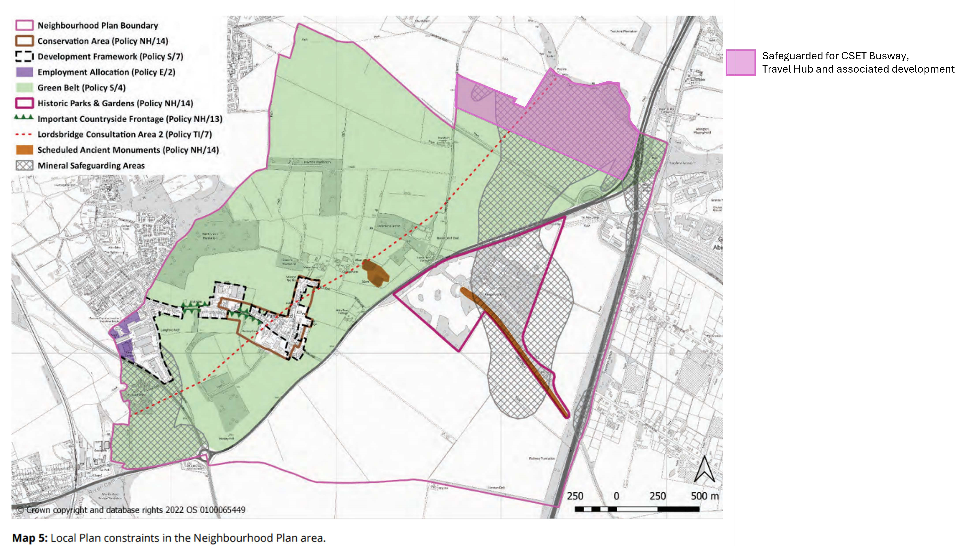

All representations : Pampisford Neighbourhood Plan Submission version

200140 Comment
Document Element: Pampisford Neighbourhood Plan Submission version, Pampisford Neighbourhood Plan Submission version
Respondent: Natural England
Date received: 27/09/2024 via Email
Summary:
Please find Natural England’s response in relation to the above mentioned consultation attached.
Full text:
Please find Natural England’s response in relation to the above mentioned consultation attached.
Attachments:
484444 NE Response.pdf - https://cambridge.oc2.uk/a/3v6dz
Page 13


Date: 27 September 2024
Our ref: 484444
Your ref: Pampisford Neighbourhood Plan

Mr Jonathan Dixon  Greater Cambridgeshire Planning  BY EMAIL ONLY  Neighbourhood.Planning@greatercambridgeplanning.org | Hornbeam House  Crewe Business Park  Electra Way  Crewe  Cheshire  CW1 6GJ  T 0300 060 3900

Dear Mr Dixon

Pampisford Neighbourhood Plan - Regulation 16 Consultation

Thank you for your consultation on the above dated 05 August 2024.

Natural England is a non-departmental public body. Our statutory purpose is to ensure that the natural environment is conserved, enhanced, and managed for the benefit of present and future generations, thereby contributing to sustainable development.

Natural England is a statutory consultee in neighbourhood planning and must be consulted on draft neighbourhood development plans by the Parish/Town Councils or Neighbourhood Forums where they consider our interests would be affected by the proposals made.

Natural England does not have any specific comments on this draft neighbourhood plan.

However, we refer you to the attached annex which covers the issues and opportunities that should be considered when preparing a Neighbourhood Plan and to the following information.

Natural England does not hold information on the location of significant populations of protected species, so is unable to advise whether this plan is likely to affect protected species to such an extent as to require a Strategic Environmental Assessment. Further information on protected species and development is included in Natural England's Standing Advice on protected species .

Furthermore, Natural England does not routinely maintain locally specific data on all environmental assets. The plan may have environmental impacts on priority species and/or habitats, local wildlife sites, soils and best and most versatile agricultural land, or on local landscape character that may be sufficient to warrant a Strategic Environmental Assessment. Information on ancient woodland, ancient and veteran trees is set out in Natural England/Forestry Commission standing advice.

We therefore recommend that advice is sought from your ecological, landscape and soils advisers, local record centre, recording society or wildlife body on the local soils, best and most versatile agricultural land, landscape, geodiversity and biodiversity receptors that may be affected by the plan before determining whether a Strategic Environmental Assessment is necessary.

Natural England reserves the right to provide further advice on the environmental assessment of the plan. This includes any third party appeal against any screening decision you may make. If an Strategic
Environmental Assessment is required, Natural England must be consulted at the scoping and environmental report stages.

For any further consultations on your plan, please contact: consultations@naturalengland.org.uk.

Yours sincerely
Sally Wintle
Consultations Team

Annex 1 - Neighbourhood planning and the natural environment: information, issues and opportunities
Natural environment information sources
The Magic website will provide you with much of the nationally held natural environment data for your plan area. The most relevant layers for you to consider are: Agricultural Land Classification, Ancient Woodland, Areas of Outstanding Natural Beauty, Local Nature Reserves, National Parks (England), National Trails, Priority Habitat Inventory, public rights of way (on the Ordnance Survey base map) and Sites of Special Scientific Interest (including their impact risk zones). Local environmental record centres may hold a range of additional information on the natural environment. A list of local record centres is available from the Association of Local Environmental Records Centres .
Priority habitats are those habitats of particular importance for nature conservation, and the list of them can be found here. Most of these will be mapped either as Sites of Special Scientific Interest, on the Magic website or as Local Wildlife Sites. Your local planning authority should be able to supply you with the locations of Local Wildlife Sites.
National Character Areas (NCAs) divide England into 159 distinct natural areas. Each character area is defined by a unique combination of landscape, biodiversity, geodiversity and cultural and economic activity. NCA profiles contain descriptions of the area and statements of environmental opportunity, which may be useful to inform proposals in your plan. NCA information can be found here.
There may also be a local landscape character assessment covering your area. This is a tool to help understand the character and local distinctiveness of the landscape and identify the features that give it a sense of place. It can help to inform, plan and manage change in the area. Your local planning authority should be able to help you access these if you can’t find them online.
If your neighbourhood planning area is within or adjacent to a National Park or Area of Outstanding Natural Beauty (AONB), the relevant National Park/AONB Management Plan for the area will set out useful information about the protected landscape. You can access the plans on from the relevant National Park Authority or Area of Outstanding Natural Beauty website.
General mapped information on soil types and Agricultural Land Classification is available (under ’landscape’) on the Magic⁴ website and also from the LandIS website, which contains more information about obtaining soil data.
Natural environment issues to consider
The National Planning Policy Framework sets out national planning policy on protecting and enhancing the natural environment. Planning Practice Guidance sets out supporting guidance.
Your local planning authority should be able to provide you with further advice on the potential impacts of your plan or order on the natural environment and the need for any environmental assessments.

Landscape
Your plans or orders may present opportunities to protect and enhance locally valued landscapes. You may want to consider identifying distinctive local landscape features or characteristics such as ponds, woodland or dry stone walls and think about how any new development proposals can respect and enhance local landscape character and distinctiveness.
If you are proposing development within or close to a protected landscape (National Park or Area of Outstanding Natural Beauty) or other sensitive location, we recommend that you carry out a landscape assessment of the proposal. Landscape assessments can help you to choose the most appropriate sites for development and help to avoid or minimise impacts of development on the landscape through careful siting, design and landscaping.

Wildlife habitats
Some proposals can have adverse impacts on designated wildlife sites or other priority habitats (listed here), such as Sites of Special Scientific Interest or Ancient woodland. If there are likely to be any adverse impacts you’ll need to think about how such impacts can be avoided, mitigated or, as a last resort, compensated for.

Priority and protected species
You’ll also want to consider whether any proposals might affect priority species (listed here ) or protected species. To help you do this, Natural England has produced advice here¹¹ to help understand the impact of particular developments on protected species.

Best and Most Versatile Agricultural Land
Soil is a finite resource that fulfils many important functions and services for society. It is a growing medium for food, timber and other crops, a store for carbon and water, a reservoir of biodiversity and a buffer against pollution. If you are proposing development, you should seek to use areas of poorer quality agricultural land in preference to that of a higher quality in line with National Planning Policy Framework para 112. For more information, see Guide to assessing development proposals on agricultural land .
Improving your natural environment
Your plan or order can offer exciting opportunities to enhance your local environment and should provide net gains for biodiversity in line with the National Planning Policy Framework. If you are setting out policies on new development or proposing sites for development, you should follow the biodiversity mitigation hierarchy and seek to ensure impacts on habitats are avoided or minimised before considering opportunities for biodiversity enhancement. You may wish to consider identifying what environmental features you want to be retained or enhanced or new features you would like to see created as part of any new development and how these could contribute to biodiversity net gain and wider environmental goals.
Opportunities for environmental enhancement might include:
- Restoring a neglected hedgerow.
- Creating a new pond as an attractive feature on the site.
- Planting trees characteristic to the local area to make a positive contribution to the local landscape.
- Using native plants in landscaping schemes for better nectar and seed sources for bees and birds.
- Incorporating swift boxes or bat boxes into the design of new buildings.
- Think about how lighting can be best managed to reduce impacts on wildlife.
- Adding a green roof to new buildings.
- Providing a new footpath through the new development to link into existing rights of way.

Site allocations should be supported by a baseline assessment of biodiversity value. The statutory
Biodiversity Metric may be used to understand the number of biodiversity units present on allocated sites. For small development allocations the Small Sites Metric may be used. This is a simplified version of the statutory Biodiversity Metric and is designed for use where certain criteria are met. Further information on biodiversity net gain including planning practice guidance can be found here

You may also want to consider enhancing your local area in other ways, for example by:
- Setting out in your plan how you would like to implement elements of a wider Green Infrastructure Strategy (if one exists) in your community.
- Assessing needs for accessible greenspace and setting out proposals to address any deficiencies or enhance provision. Natural England’s Green Infrastructure Framework sets out further information on green infrastructure standards and principles
- Identifying green areas of particular importance for special protection through Local Green Space designation (see Planning Practice Guidance¹³).
- Managing existing (and new) public spaces to be more wildlife friendly (e.g. by sowing wild flower strips in less used parts of parks or on verges, changing hedge cutting timings and frequency).

- Planting additional street trees.
- Identifying any improvements to the existing public right of way network, e.g. cutting back hedges, improving the surface, clearing litter or installing kissing gates) or extending the network to create missing links.
- Restoring neglected environmental features (e.g. coppicing a prominent hedge that is in poor condition, or clearing away an eyesore).

Natural England’s Environmental Benefits from Nature tool may be used to identify opportunities to enhance wider benefits from nature and to avoid and minimise any negative impacts. It is designed to work alongside the statutory Biodiversity Metric and is available as a beta test version.

All representations : Pampisford Neighbourhood Plan Submission version

200141 Comment

Document Element: Pampisford Neighbourhood Plan Submission version, Pampisford Neighbourhood Plan Submission version
Respondent: British Horse Society
Date received: 23/09/2024 via Email
Summary:
Comments on behalf of the British Horse Society:
ROUTES SUITABLE FOR NON-MOTORISED USERS IN AND AROUND THE PARISH.
6.10.6
It is acknowledged at both national and local level that equestrians are NMU's. We support many of the comments about the cycling provision being inadequate and unsafe. Equestrians are considered equally vulnerable road users as cyclists in the Road User Hierarchy. The Highway Code states that cyclists should not undertake equestrians.
Provision of roadside cycling routes which exclude equestrians leaves horse and their riders, as well as other road users, in more danger. It brings fast-moving cyclists on the inside of equestrians forced to travel in the traffic flow, Horses are not trained to expect traffic on their inside and may be startled by cyclists and swing out into the path of vehicles. If the cycling provision is built to accommodate cargo, hand propelled and recumbent bikes, then it will be wide enough to include equestrians.
Equestrians are entitled to use the whole of the highway which comprises the carriageway and the verge. Construction of a cycle path on the verge should be subject to a TRO which requires consultation with Stakeholders including the BHS. The BHS would require equestrian inclusion on any safe paths provided on the verge.
A route which is currently signed for pedestrians and cyclists only and should be available to equestrians is the path from the edge of the village on Babraham Road along Sawston Road to Babraham. Part of this route is in Pampisford and part in Babraham. The path should be upgraded to bridleway status and this should be included within the Plan 'wish list. There is a possibility that the CSET project will address this incorrect signage. This path is so dangerous, it was used to highlight the danger of excluding equestrians from safe off-road access in a BHS safety leaflet. See attached.
Since the preparation of the NP Plan, a bridleway has been created in the Parish. See attached an image of the bridleway.
There is a clear opportunity to improve both the PROW network for both cyclists and equestrians by upgrading two footpaths to bridleways with appropriate surfacing for all users - not tarmac. Footpaths 179/1 Pampisford leading to footpaths 12/9 and 12/8 Babraham, and footpath 179/2 Pampisford. See attached an image of the footpaths.
Should CSETs be delivered, then there will be further opportunities for links from these two new bridleways with the proposed bridleway running alongside the busway. See attached an Image of the CSET Better Public Transport Route.
Whilst the upgrades are not within the gift of this Plan, they should be included on the 'wish list' for future opportunities.
Full text:
Thank you for including Equestrians in the Plan. Comments on Behald of the Biritsh Horse Society:
Comments on behalf of the British Horse Society:
ROUTES SUITABLE FOR NON-MOTORISED USERS IN AND AROUND THE PARISH.
6.10.6
It is acknowledged at both national and local level that equestrians are NMU's.
We support many of the comments about the cycling provision being inadequate and unsafe. Equestrians are considered equally vulnerable road users as cyclists in the Road User Hierarchy. The Highway Code states that cyclists should not undertake equestrians.
Provision of roadside cycling routes which exclude equestrians leaves horse and their riders, as well as other road users, in more danger. It brings fast-moving cyclists on the inside of equestrians forced to travel in the traffic flow, Horses are not trained to expect traffic on their inside and may be startled by cyclists and swing out into the path of vehicles. If the cycling provision is built to accommodate cargo, hand propelled and recumbent bikes, then it will be wide enough to include equestrians.
Equestrians are entitled to use the whole of the highway which comprises the carriageway and the verge. Construction of a cycle path on the verge should be subject to a TRO which requires consultation with Stakeholders including the BHS. The BHS would require equestrian inclusion on any safe paths provided on the verge.
A route which is currently signed for pedestrians and cyclists only and should be available to equestrians is the path from the edge of the village on Babraham Road along Sawston Road to Babraham. Part of this route is in Pampisford and part
Page 14
All representations : Pampisford Neighbourhood Plan Submission version
in Babraham. The path should be upgraded to bridleway status and this should be included within the Plan 'wish list. There is a possibility that the CSET project will address this incorrect signage. This path is so dangerous, it was used to highlight the danger of excluding equestrians from safe off-road access in a BHS safety leaflet. See attached.
Since the preparation of the NP Plan, a bridleway has been created in the Parish.
(Image attached)
There is a clear opportunity to improve both the PROW network for both cyclists and equestrians by upgrading two footpaths to bridleways with appropriate surfacing for all users - not tarmac. Footpaths 179/1 Pampisford leading to footpaths 12/9 and 12/8 Babraham, and footpath 179/2 Pampisford.
(Image attached)
Should CSETs be delivered, then there will be further opportunities for links from these two new bridleways with the proposed bridleway running alongside the busway. (Image attached)
Whilst the upgrades are not within the gift of this Plan, they should be included on the 'wish list' for future opportunities.
Attachments:
Image of CSET Better Public Transport route.png - https://cambridge.oc2.uk/a/3v6dm
Image of Footpaths.png - https://cambridge.oc2.uk/a/3v6dn Image of the proposed bridleway running alongside the busway.png https://cambridge.oc2.uk/a/3v6dy
Cyclists Horse Riders Leaflet - Sawston path.pdf - https://cambridge.oc2.uk/a/3v6dp

Page 15

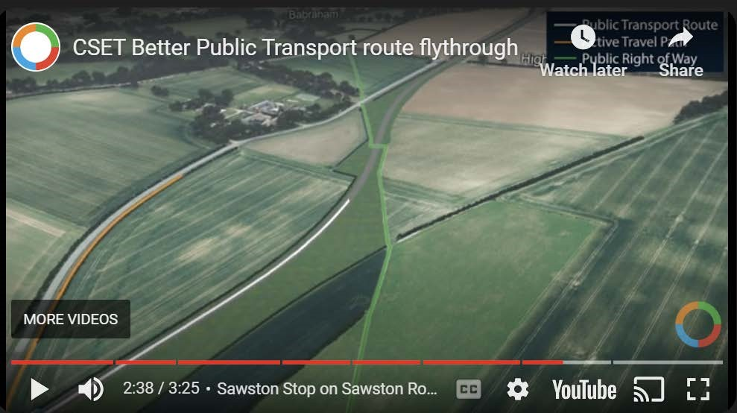

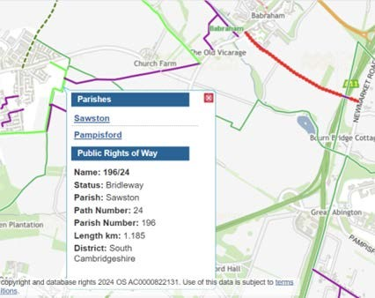

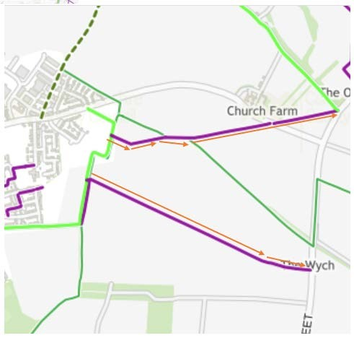




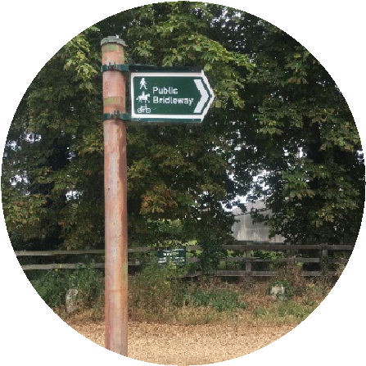
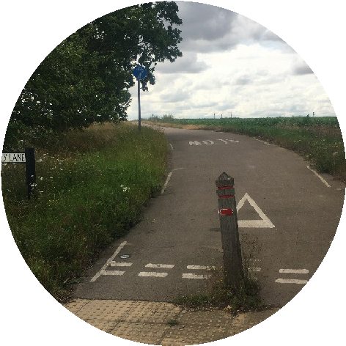
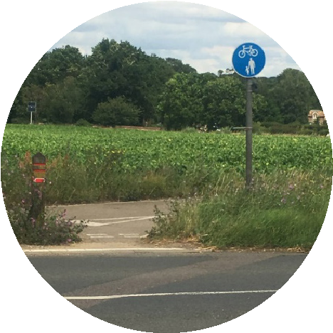
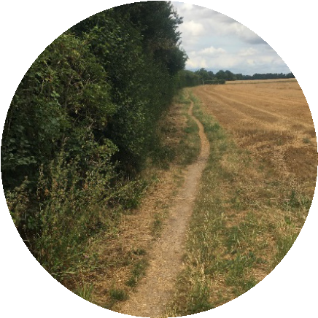
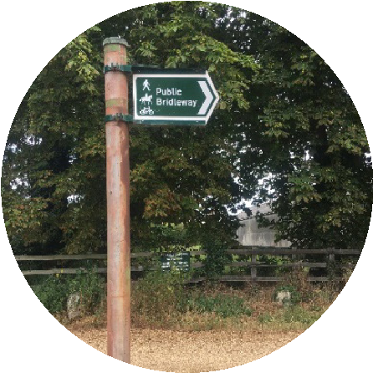
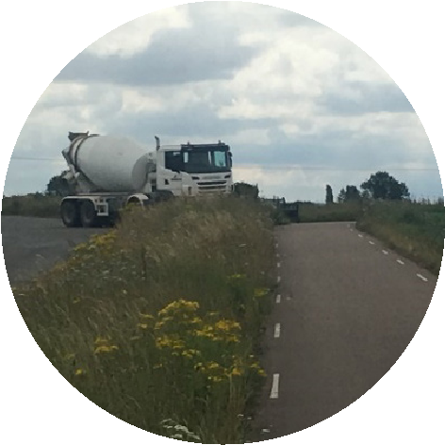
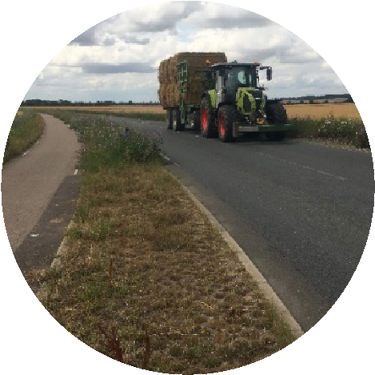

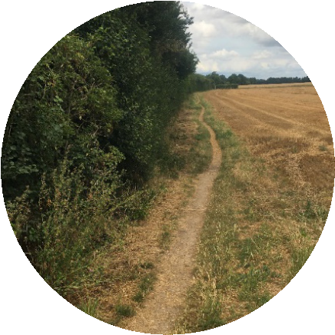


Walkers and cyclists
Equestrians
The Impact of Active Travel and Cycling and
Walking Strategies - a real example
At the end of the
bridleway walkers
and cyclists can
proceed safely on
a cycle path, horse
riders have to face
traffic
Walkers and
cyclists cross
over to another
cycle path -
horse riders
have to continue
on the busy road
Finally, all can
finish the route
on another
bridleway
Since 2010, we have had over 12,115 road incidents involving horses reported to us, 1,436 horses have
been injured, 570 horses have died, 44 humans have lost their lives and 1,592 been injured.
Walkers, cyclists
and horse riders
start together on a
bridleway
1
2
3
4
The British Horse Society 2023. Charity number: 210504, Scottish Charity number: SC038516

All representations : Pampisford Neighbourhood Plan Submission version

200142 Comment
Document Element: Pampisford Neighbourhood Plan Submission version, Pampisford Neighbourhood Plan Submission version
Respondent: Lead Local Flood Authority (LLFA)
Date received: 27/09/2024 via Email
Summary:
Please see the attached comment from the LLFA for the Pampisford Neighbourhood Plan.
Full text:
Please see the attached comment from the LLFA for the Pampisford Neighbourhood Plan.
Attachments:
Pampisford Neighbourhood Plan.pdf - https://cambridge.oc2.uk/a/3v6dq
Page 16

Thank you for consulting us on the Pampisford Neighbourhood Plan.

I have reviewed the Pampisford Neighbourhood Plan and have the following comments:

It was noted that the applicant has acknowledged the flood risk in the Pampisford area sufficiently. Small areas of flood zone 2 and 3 fluvial flood risk are identified to the south of the village and in areas to the north. Surface water flood risk is low within most of the plan boundary, some areas of ponding occur due to the contours of the land or from existing ditches and watercourses.

- It is recommended to include reference to the Cambridgeshire Flood and Water SPD to seek advice and guidance on surface water management in development. This document is adopted by South Cambridgeshire District Council. The SPD can be found on the following link: Cambridgeshire Flood and Water Supplementary Planning Document.
- Reference can be made to our Surface Water Planning Guidance document which can be found at: Surface Water Planning Guidance - June 2024 (cambridgeshire.gov.uk).
- Policies CC/7, CC/8 and CC/9 are of particular importance in the South Cambridgeshire District Council local plan (or any subsequent version of this plan) which can be found at: South Cambridgeshire Adopted Local Plan 2018 (scambs.gov.uk)
- Reference can be made to Chapter 14 of the NPPF also, this can be found at: National Planning Policy Framework (publishing.service.gov.uk)

If you require assistance or a meeting regarding the Neighbourhood Plan, please let me know and we can look to arrange a time for a virtual meeting.

If you require any clarification, please do not hesitate to contact me.

Kind regards

All representations : Pampisford Neighbourhood Plan Submission version

200143 Comment
Document Element: Pampisford Neighbourhood Plan Submission version, Pampisford Neighbourhood Plan Submission version
Respondent: Greater Cambridge Shared Planning
Date received: 30/09/2024 via Email
Summary:
Please see attached the Council’s formal response to the Pampisford Neighbourhood Plan Regulation 16 submission consultation.
Full text:
Please see attached the Council’s formal response to the Pampisford Neighbourhood Plan Regulation 16 submission consultation.
Attachments:
Pampisford Neighbourhood Plan Regulation 16 Council Response.pdf https://cambridge.oc2.uk/a/3v6wr
Page 17

South Cambridgeshire District Council response to Pampisford Neighbourhood Plan Regulation 16 Submission Consultation
- South Cambridgeshire District Council (SCDC) is taking the opportunity to comment further on the Submission version (Regulation 16) of the Pampisford
Neighbourhood Plan. The District Council previously commented on the PreSubmission (Regulation 14) draft of the plan that was consulted on in November 2023.

- SCDC has worked with Pampisford Parish Council during the preparation of the plan. We appreciate the hard work that has gone into getting the neighbourhood plan this far along in the process.

- We note that the Submission version of the Pampisford Neighbourhood Plan has been revised after considering the representations received during the Pre-Submission (Regulation 14) consultation. SCDC submitted 123 comments in our Pre-Submission response, most of which have been taken into account and have resulted in revisions to the plan. We very much welcome the changes that have been made.

- There have also been meetings with the Pampisford Neighbourhood Plan group to discuss the plan as it has evolved and to support Pampisford Parish Council in preparing the Submission version of the plan.

- The comments we now make now concentrate on matters that relate directly to whether, in our opinion, the Pampisford Neighbourhood Plan meets the Basic Conditions.

Policy PAM1 – Residential development
- We consider that the first part of Policy PAM1 is not clear in terms of the delivery of homes in accordance with Part M4 (2) of the Building Regulations.
SCDC Local Plan Policy H/9 (Housing Mix) asks for 5% of homes on sites of 20 dwellings or more to be built to the accessible and adaptable M4(2) standard.

- The opening sentence of the policy states that “Infill residential development within the development framework will be supported in line with Local Plan policy…” but the second bullet point states that this means “building homes to the Building Regulations accessible and adaptable dwellings M4 (2) standard unless it can be demonstrated in a full financial appraisal that the application of the standard would make the development unviable.”

- It is unclear from the wording of the bullet point whether all new homes should be built to M4 (2) standard. If this is the case, then it would exceed rather than be “in line with” the Local Plan policy.

- In relation to achieving homes built to M4 (3) standard, it seems that this is an aspiration rather than a requirement of an infill plot development given the opening “will be supported” statement? As such, proposals that otherwise meet the requirement of Policy PAM1 could not be refused if they were not built to M4 (3) standard.

- In the final paragraph we note that proposals that meet the very exceptional circumstances of Local Plan Policy S/11 will only be supported where affordable housing is delivered as part of the proposal. Such an approach is contrary to paragraph 65 of the NPPF (December 2023) which states “Provision of affordable housing should not be sought for residential developments that are not major developments,”

Policy PAM2 – Rural exceptions housing in Pampisford
11. Our Pre-Submission response suggested that Policy PAM2 appeared quite similar to Policy H/11 (Rural Exception Site Affordable Housing) from the adopted South Cambridgeshire Local Plan (2018), so it could be removed unless it was demonstrated that there was a distinct difference that would apply to Pampisford. We continue to question whether Policy PAM2 is needed in addition to the adopted Local Plan policy.

Policy PAM3 – Maintaining and enhancing landscape character in Pampisford
- There is a close relationship between this policy and Policy PAM11, and it is questioned whether the reference to trees is required here given the more thorough criteria of PAM11. In the case of this policy, inclusion of the wording ‘retain or enhance existing landscape features’ does not cover instances where trees have little amenity value and would potentially need to be removed to facilitate a development, such as instances where trees are of poor quality/ diseased and/or would have limited visual impact if removed. We suggest adding wording to give greater clarity to the policy. In addition, clarity on what a ‘generous and comprehensive landscape buffer’ is required, ensuring that it is being proportionate to the development and what scale of development this would apply to. For example, would this include householder (extensions)?
- In supporting text at paragraph 6.3.9 is a list of design code numbering and we recommend it would be beneficial to include wording to give more explanation from the design code as to what those sections says.

Policy PAM4 – London Road street scene improvement area
- Our Pre-Submission response recommended that perhaps more photos would help illustrate the problems with the street scene. Other aspects of the street scenes to consider could be footway surface quality, widths of streets and footways, how well maintained they are, green verges, signage, barriers, less safe or less visible sections, and poor street lighting. Is it the case that the Brewery Road/London Road village gateway is satisfactory in terms of these other aspects as a point of contrast with the problems identified?

We still consider that the Plan content on this matter is rather slight. We would expect more commentary and analysis to justify the policy, explaining what is so incoherent and unattractive about the area. Perhaps more photos would help illustrate the problems with the street scene or going into detail about different sections along the London Street / Brewery Road.
Perhaps the policy context and rationale could consider other aspects of the street scenes e.g. footway surface quality, widths of streets and footways, how well maintained are they, green verges, too much signage and clutter, barriers / obstacles, less safe / less visible sections, lack of street trees or poor street lighting, although it must be acknowledged that some aspects of change to the street scene do not require planning consent as if they are in the highway they are deemed as permitted development.

- Our Pre-Submission response stated that Policy PAM4 does not refer to the type or scale of development where contributions are sought. The policy might not be suitable for all types and scales of development. We recommended that reference was made to the type or scale of development where contributions are sought within the Policy wording. We still consider that this clarity is required in the policy.

- Our Pre-Submission response stated Cambridgeshire County Council had concerns about the deliverability of this policy and to seek information about who owned the pathway and hedges next to the road. Was it the businesses or Cambridgeshire County Council? Then, depending on the owner, change the policy emphasis to ensure that the policy is strong enough to capture contributions efficiently. For example, if the County Council owns the hedges and pathway, then it would make sense to emphasise using contributions to improve the ‘public realm’ of that area. However, if the hedges and pathways are owned by the businesses, with little publicly owned land, then the policy needs to change to place the onus upon the businesses to improve the land next to the road as part of any future proposals. The neighbourhood plan group was encouraged to a contact the County Council to find out about the extent of the adopted highway to see if the County Council owns all road and the land next to it.

We note that Policy PAM4 has been amended but we continue to recommend that in PAM4 policy wording is given further clarity to ensure any appropriate development may be required to deliver or make financial contributions, as currently the policy wording in the final paragraph is highlighting public realm alone.

- Our Pre-Submission response recommends that if there are requests for public realm or play equipment improvements, these improvements should be inclusive for users and if they have guardians with them. We continue to recommend this approach.

Policy PAM5 – Local Green Spaces
18. We recommend the additional wording to PAM5 policy after Local Green Space sites to include “Development proposals within the designated local green spaces will only be supported in very special circumstances.” to ensure it aligns with national policy requirements.

Policy PAM7 – Pampisford Village allotments
- Our Pre-Submission response recommended that policy PAM7 could also be refined to reflect adopted South Cambridgeshire Local Plan policy SC/8, e.g., allotments would be replaced by an area of equivalent or better quantity and quality and in a suitable location. We still consider this clarity should be provided in Policy PAM7.

- We also suggest that for clarity, an additional sentence should be added to the supporting text to confirm that although the community would like to see further use of the village hall (which is included as a community action), it is considered that Policy SC/3 in the adopted Local Plan provides sufficient protection for this facility and therefore no specific policy for the village hall is included in the Neighbourhood Plan.

Policy PAM10 – Sustainable work-life patterns
- Our Pre-Submission response stated that we felt that this policy replicated adopted South Cambridgeshire Local Plan policy. Cycle and electric parking are already covered by Policy TI/2 ‘Planning for Sustainable Travel’ from South Cambridgeshire’s Local Plan. Electric car parking is covered by policy TI/3 ‘Parking Provision’ and policy TI/10 ‘Broadband’ already covers broadband. It is also likely to be covered in the new Local Plan. PAM10 should be demonstrably different, and local in nature, compared to the Local Plan policies.

- Our Pre-Submission response questioned how the requirement to incorporate a dedicated home office area could be monitored and enforced? We still have concerns regarding this, in particular how this will be delivered alongside PAM1 requirements for smaller units and be viable.

Policy PAM11 - Trees and woodland
- We suggest adding wording to add clarity to the policy as a tree survey to BS5837 will not identify ecological value, suggest wording 'will be expected to be accompanied by a professional arboricultural survey report undertaken to the appropriate standards (to BS5837) and a preliminary ecological survey identifying the arboricultural landscape and biodiversity value of the trees’. Additionally, we recommend that Biodiversity Net Gain wording, as statutory requirement it can be removed from the policy PAM11 wording.

- We recommend adding wording to point 2 of the policy, regarding financial contribution, to clarify to what trees; sizes and values, would the contribution apply.

- We recommend the compensatory provision wording in section 3 of PAM 11, that the industry accepted calculation method would now be covered by BNG rather than CAVAT.

Policy PAM12 – Protecting and enhancing biodiversity in Pampisford Parish
- The policy has two sets of Roman numerals which will make it difficult for those using the Plan to refer to. Would recommend that one of the sets becomes a) b) etc

- We recommend that Biodiversity Net Gain wording, as statutory requirement, can be removed from the policy PAM12 wording.

Policy PAM 13 – Development, movement and traffic
28. Policy TI/3: Parking Provision of the adopted Local Plan states that car parking provision should be provided through a design-led approach in accordance with the indicative standards set out in Figure 11 of the Plan. We suggest that the second paragraph of the PAM13 should refer to the Parking Standards in the extant adopted local plan.

The Highway Authority can only seek works that directly mitigate the impact of a development, so the use of ‘quiet tyre technology’ would fall outside our remit and would also require careful consideration in relationship to its life span and durability.’’ The visual impact of additional vehicle movements would also be difficult to measure and define. We suggest this is removed from PAM13 policy wording.

Policy PAM 14 – Preventing environmental pollution from Pampisford businesses
- Our Pre-Submission response questioned why the policy is asking for an assessment of potential pollution when the South Cambridgeshire Local Plan already asks for assessments on development through policies SC/10-Noise pollution, 9.54 ‘’noise impact assessment’’, SC/12-Air Quality, 7. ‘relevant assessment’, SC/14- Odour and Other Fugitive Emissions to Air 2 and SC/HQ-1 n, and CC/1. PAM14 should be demonstrably different, and local in nature, compared to the Local Plan policies.
- Our Pre-Submission response stated that there were not clear environmental receptors (areas which are places that could be harmed by pollution, i.e. parks, wildlife habitats) identified in the policy. We continue to suggest that Policy PAM14 should include clearly identified environmental receptors that must be considered.

Policy PAM 15 – Brewery Road employment
31. We recommend that that wording is added to PAM15 to reference PAM3, which is concerned with development abutting the Development Framework and a requirement to include a generous countryside buffer, which would appropriate and relevant to PAM15.

Policy PAM 16 – London Road employment area
32. Our Pre-Submission response queried whether either of the policy points in PAM16 were distinct from PAM4? We continue to suggest the two policies are not demonstrably distinct from each other, are both policies required?

Policy PAM 17 – Rectory Farm employment area
- Our Pre-Submission response highlighted that the use of the word “harmony” is not generally used when it comes to considering the impact of development on heritage assets, and instead we highlighted paragraphs 199 to 208 of the NPPF which identifies that the impact on heritage assets should be measured
in terms of “harm”. We note that the wording in policy PAM17 has been amended, however, we recommend further adapting the policy wording of the second point to read: “Development preserving or enhancing heritage assets...”, to ensure robust policy wording.

- Regarding Rectory Farm Meadows in the supporting text at paragraph 6.17.1. As these meadows appear to be within the conservation area, we recommend replacing the fourth sentence that starts with ‘Rectory Farm Meadows …’ with a sentence such as: “The special contribution which the open space at Rectory Farm meadows makes to the conservation area (see Map 5) should be conserved or strengthened.” We further recommend the extent of Rectory Farm Meadows, and the Conservation Area, are illustrated on one map to provide clarity over how the different areas relate to each other.

Policy PAM 18 – Protecting and enhancing access to and enjoyment of the countryside
- We suggest including supporting text that where planning consent is required that new country walking routes, and access to woodland, should include gateways and styles that are accessible for mobility scooter users, wheelchair users and walkers using sticks for guidance or balance. If any pathway surfaces are constructed these surfaces need be usable by these groups as well.

- We recommend the second paragraph of policy PAM18 is moved from the policy into the supporting text as planning applications cannot create a public right of way.

- We suggest replacement wording “Measures to improve and extend the existing network of public rights of way and bridleways will be supported particularly if their value as biodiversity corridors is recognised and safeguarded”.

Policy PAM 19 – Local heritage and non-designated heritage assets
- We recommend that at paragraph three of PAM19 the policy wording should read “preserve or enhance” not “conserve and enhance”.

- In the fourth part of policy PAM19, we recommend that the heritage statement provided should be “proportionate to the assets’ importance and sufficient to understand the potential impact of the proposal”, rather than proportionate to the scale of the development.

General comments on the Pampisford Neighbourhood Plan
40. Whilst it is not a requirement to monitor a neighbourhood plan, we recommend including a section on monitoring as it will ensure that the Parish Council are able to review how effective policies are in practice and know when it is necessary to undertake a review of the Neighbourhood Plan.

Maps
- On page 7, paragraph 1.8 you have included wording “It should be noted that there is not one parish-wide Policies Map provided as part of this version of the NP. Instead, where a planning policy in Chapter 6 has site-specific implications, a policy map showing this is placed after the policy.” We suggest that the wording is amended to highlight that the policies maps are those referenced within the wording of the policies and suggest rewording paragraph 1.8 as “It should be noted that there is not one parish-wide
Policies Map provided as part of this version of the Neighbourhood Plan. Instead, where a planning policy has site-specific implications, a policies map showing the policy extent is included for that specific policy and referenced within the policy wording.”

- Map 10, page 57, is not referenced within any policy or supporting text, and therefore we suggest the map is not required. Or, that a reference is added within the supporting text or policy wording of policy PAM10.

- Map 13, page 72, shows four employment areas, however policies PAM14 to PAM17 only relate to three employment areas. The fourth employment area identified on the map is referenced in the supporting text, and that same supporting text references a fifth employment area, but the map only includes one of these two additional employment areas. For clarity, we recommend that Map 13 should differentiate between the employment areas covered by Policies PAM14 to PAM17, and the additional employment areas shown for information only. We also recommend that both additional employment areas should be highlighted on the map, or that neither are shown on the map.

- We suggest it would be helpful to have all heritage assets on one map and in the format of Map 16 which is easier to read. Clarity would be required on the map that it is only the NDHAs that go with the policy (PAM19), and the Listed Buildings and Conservation Area are shown for illustrative purposes only.

Plan period
45. Our Pre-Submission response noted that the plan period is to 2041, whereas the adopted South Cambridgeshire Local Plan covers the period to 2031. The Council is preparing a new joint Local Plan that will extend into the 2040’s, but this process is not expected to conclude until after the neighbourhood plan has been adopted. This may result in future in differences between the two plans reflecting the context within which both plans are being prepared. We will nevertheless seek to minimise any potential policy conflicts through that process, but it is important to be aware of the possibility of such conflict at this stage.

Grammar and typographic matters
46. We note that the references to the NPPF will need to be updated once a new NPPF has been published later in 2024, and these minor amendments can be made alongside any changes being made following examination of the Neighbourhood Plan.

Chapters 1 to 5
47. Our Pre-Submission response recommended that in chapter 3 evidence supporting the neighbourhood plan could also refer to South Cambridgeshire District Design Guide (2010) as this is an adopted SPD. In the District Design Guide, Pampisford is part of the ‘Chalklands’ character where a series of design principles are stated. Recently ‘made’ neighbourhood plans in Waterbeach and Gamlingay refer to the District Design Guide. It also highlighted the National Design Guide (2021). We continue to recommend the inclusion of this evidence and further to include a reference to the National Design Guide (2019) by the Ministry of Housing, Communities and Local Government.

Chapter 6
48. We note that a number of the policies could be amended to be positively worded as per the NPPF (2023) paragraph 16, b. For example, removing terms like ‘will not be supported’.

Appendices/Supporting Evidence documents

Appendix One: The Design Guidance and Codes for Pampisford
49. We note that Appendix One is now an updated version of the Design Code due to agreed changes made through consultation responses. We suggest that wording is added throughout the Neighbourhood Plan to make clear that the Appendix One version of the Design Code is the version to use when making decisions on planning applications, and that it takes precedence over the 2021 version.

Appendix Three: Locally important views and their key features
50. For the sake of completeness, it would be helpful to the user if reference was made to Map 6 at the start of the appendix in order that it can be seen where the viewpoint is.

All representations : Pampisford Neighbourhood Plan Submission version

200145 Comment

Document Element: Pampisford Neighbourhood Plan Submission version, Pampisford Neighbourhood Plan Submission version
Respondent: Solopark Ltd Agent: Carter Jonas
Date received: 30/09/2024 via Web
Summary:
The draft Pampisford Neighbourhood Plan identifies a clear need for smaller single storey market dwellings. However, under the current plan, this need is unlikely to be met. It is questioned whether the plan will be found sound on this basis. It is requested that: the allocation of sites for housing development be reconsidered; and/or the development framework boundary be extended to include Site 4 and other suitable sites; and/or Policy PAM1 be reworded to allow housing development outside of, but adjacent to, the settlement boundary for Pampisford on sites which fall outside of the Green Belt.
Full text:
The draft Pampisford Neighbourhood Plan (PNP) identifies a clear need for additional housing in Pampisford, including a need for market housing. It advises at Paragraph 6.1.10 that open market properties do not become available frequently and there is evidence that, when they do become available, they are not suitable to meet the needs of residents looking to move whilst staying in the parish, via the open market. It states that:
“The 2020 HNS identified six households seeking to address their housing issues through the open market. All bar one were looking to downsize. Two were interested in self-build and four (including self-builders) were seeking bungalows. The majority of people concerned were aged 60+”.
Therefore, there is a clear need for smaller single storey market dwellings to allow older residents to downsize.
However, despite this identified need, the decision has been taken not to allocate any sites for housing development within the draft PNP. It is understood this decision has been taken due to the additional work involved (i.e. the preparation of a Strategic Environmental Assessment and a Habitat Regulation Assessment). However, it is questioned whether the draft PNP will be found sound when a clear need for market housing has been identified without any provisions for how that need will be met.
Without development allocations the only way for new housing to come forward is through windfall development on sites within the development framework. However, due to the tightly drawn development framework boundary, there is limited opportunity for housing development within the development framework for Pampisford, thus little opportunity for new market housing to come forward in the settlement under the current plan. This is evident by the limited number of applications approved for housing development in recent years. A search of applications approved over the past five years identified only one application approved for residential development within the PNP area during this period (Application Ref. 20/01181/FUL for 4no. dwellings on London Road, on the edge of the Neighbourhood Plan Area adjacent to Sawston). No housing applications have been approved within the central area of Pampisford during this time.
Therefore, the draft PNP identifies a clear need for smaller single storey market dwellings to allow older residents to downsize, however, under the current plan, it is unlikely this need will be met. It is questioned whether the plan will be found sound on this basis. It is therefore requested that: the allocation of sites for housing development be reconsidered; and/or the development framework boundary be extended to include Site 4 and other such suitable sites; and/or Policy PAM1 be reworded to allow infill development outside of, but adjacent to, the settlement boundary for Pampisford on sites which fall outside of the Green Belt. These amendment would allow additional market housing to come forward to meet the identified need.
Attachments: None

Page 18
All representations : Pampisford Neighbourhood Plan Submission version

200151 Comment

Document Element: Pampisford Neighbourhood Plan Submission version, Pampisford Neighbourhood Plan Submission version
Respondent: National Grid
Date received: 30/09/2024 via Email
Summary:
Please find our letter of representation on behalf of National Grid Electricity Transmission attached.
Full text:
Please find our letter of representation on behalf of National Grid Electricity Transmission attached.
Attachments:
National Grid 30-09-24 Pampisford.pdf - https://cambridge.oc2.uk/a/3v6w5

Page 19

Our Ref: MV/ 15B901605

30 September 2024

South Cambridgeshire District council neighbourhood.planning@greatercambridgeplanning.org via email only

Dear Sir / Madam
Pampisford Neighbourhood Plan – Submission public consultation
August – September 2024
Representations on behalf of National Grid Electricity Transmission

Central Square
Forth Street
Newcastle upon Tyne
NE1 3PJ

T: +44 (0)191 261 2361 F: +44 (0)191 269 0076

avisonyoung.co.uk


National Grid Electricity Transmission has appointed Avison Young to review and respond to local planning authority Development Plan Document consultations on its behalf. We are instructed by our client to submit the following representation with regard to the current consultation on the above document.

About National Grid Electricity Transmission
National Grid Electricity Transmission plc (NGET) owns and maintains the electricity transmission system in England and Wales. The energy is then distributed to the electricity distribution network operators, so it can reach homes and businesses.

National Grid no longer owns or operates the high-pressure gas transmission system across the UK. This is the responsibility of National Gas Transmission, which is a separate entity and must be consulted independently.

National Grid Ventures (NGV) develop, operate and invest in energy projects, technologies, and partnerships to help accelerate the development of a clean energy future for consumers across the UK, Europe and the United States. NGV is separate from National Grid’s core regulated businesses. Please also consult with NGV separately from NGET.

Proposed development sites crossed or in close proximity to NGET assets:
An assessment has been carried out with respect to NGET assets which include high voltage electricity assets and other electricity infrastructure.

NGET has identified that no assets are currently affected by proposed allocations within the Neighbourhood Plan area.

NGET provides information in relation to its assets at the website below.

• www2.nationalgrid.com/uk/services/land-and-development/planning-authority/shapefiles/
Avison Young (UK) Limited registered in England and Wales number 6382509.
Registered office, 3 Brindleyplace, Birmingham B1 2JB. Regulated by RICS
Please also see attached information outlining guidance on development close to NGET infrastructure.

Distribution Networks
Information regarding the electricity distribution network is available at the website below:
www.energynetworks.org.uk

Further Advice
Please remember to consult NGET on any Neighbourhood Plan Documents or site-specific proposals that could affect our assets. We would be grateful if you could add our details shown below to your consultation database, if not already included:

Matt Verlander, Director | Tiffany Bate, Development Liaison Officer
nationalgrid.uk@avisonyoung.com | box.landandacquisitions@nationalgrid.com
Avison Young  Central Square South  Orchard Street  Newcastle upon Tyne  NE1 3AZ | National Grid Electricity Transmission  National Grid House  Warwick Technology Park  Gallows Hill  Warwick, CV34 6DA

If you require any further information in respect of this letter, then please contact us.

Yours faithfully,

Matt Verlander MRTPI

Director

For and on behalf of Avison Young
Avison Young (UK) Limited registered in England and Wales number 6382509. Registered office, 3 Brindleyplace, Birmingham B1 2JB. Regulated by RICS 2
NGET is able to provide advice and guidance to the Council concerning their networks and encourages high quality and well-planned development in the vicinity of its assets.

Developers of sites crossed or in close proximity to NGET assets should be aware that it is NGET policy to retain existing overhead lines in-situ, though it recognises that there may be exceptional circumstances that would justify the request where, for example, the proposal is of regional or national importance.

NGET’s ‘Guidelines for Development near pylons and high voltage overhead power lines’ promote the successful development of sites crossed by existing overhead lines and the creation of welldesigned places. The guidelines demonstrate that a creative design approach can minimise the impact of overhead lines whilst promoting a quality environment. The guidelines can be downloaded here: https://www.nationalgridet.com/document/130626/download

The statutory safety clearances between overhead lines, the ground, and built structures must not be infringed. Where changes are proposed to ground levels beneath an existing line then it is important that changes in ground levels do not result in safety clearances being infringed. National Grid can, on request, provide to developers detailed line profile drawings that detail the height of conductors, above ordnance datum, at a specific site.

NGET’s statutory safety clearances are detailed in their ‘Guidelines when working near National Grid Electricity Transmission assets’, which can be downloaded here:
www.nationalgridet.com/network-and-assets/working-near-our-assets

How to contact NGET
If you require any further information in relation to the above and/or if you would like to check if NGET’s transmission networks may be affected by a proposed development, please visit the website: https://lsbud.co.uk/
For local planning policy queries, please contact: nationalgrid.uk@avisonyoung.com

Avison Young (UK) Limited registered in England and Wales number 6382509. Registered office, 3 Brindleyplace, Birmingham B1 2JB. Regulated by RICS 3

All representations : Pampisford Neighbourhood Plan Submission version

200154 Comment
Document Element: Pampisford Neighbourhood Plan Submission version, Pampisford Neighbourhood Plan Submission version
Respondent: Mr Frederick Killander
Date received: 30/09/2024 via Email
Summary:
Please find attached my comments regarding the Pampisford Neighbourhood Plan.
Full text:
Please find attached my comments regarding the Pampisford Neighbourhood Plan.
Attachments:
The Pampisford Estate response neighbourhood plan.pdf - https://cambridge.oc2.uk/a/3v6wv
Page 20

A key custodian of the Parish of Pampisford is the Pampisford Estate. It’s holdings include 2 AHA tenanted farms, in hand farm land, woodland, the village school currently used as the Village Hall, the village allotments, the Church Lane play-ground, the nature reserve, several farm yards converted for housing and employment, some coDages (mostly for employees) and a listed Hall surrounded by a naHonally important starred arboretum planted in 1820. The new A11, constructed on top of the original Roman Road and on Estate farm land, forms the eastern boundary of the Parish while the hall is separated from the Village and it’s Home Farm by the ever busier A505. As farming land falls in hand, the Estate’s team are housed near the hall and at Brent Ditch End just opposite the listed main gates.

The ethos governing the management and maintenance decisions for these assets prescribes the very best efforts to protect the flora and fauna (biodiversity) of our Parish which require and deserve space and peace. The Parish woodlands are managed as sustainable: mixed age, mixed species plantaHons (where thinning and felling is always to the best) and to increase biodiversity, carbon sequestraHon and Hmber producHon rather than the less onerous and expensive clear fell and replant method of more business minded woodland owners. The Estate’s fat A line hedges have significantly increased shelter for birds and plants in the cold winter months and the replanHng and replacement of trees lost to age and disease is intended to ensure that the rural aspect is enjoyed by generaHons to come.

The ethos is not different for the Estate’s buildings: repair and restoraHon and maintenance using the tradiHonal materials and to the highest standard of workmanship available is undertaken wherever possible. Design is governed to keep as close as possible to tradiHonal vernacular – using flint, recycled Cambridge White bricks, or tradiHonal featheredged Hmber frames with wooden glazed windows to original design and slate or thatched roofs. In consequence they are preDy, very low carbon, efficient and most importantly built to last lifeHmes.

A dilemma for the trustees is that such management precepts are o]en misunderstood and are expensive. While pressures to sell to highest bidder have been consistently resisted, change in support for farming has made it increasingly uneconomic to manage land for the amenity of all of us locals. None the less the really devastaHng loss of the Chequers Pub and so the loss of a key community facility, where so many enjoyed Hme together and the delicious food, we sHll retain a recreaHon ground, a playground, village allotments, nature reserve, village hall and an acHve and much beloved church. But it is necessary to recognize that the estate also has its needs if it is to survive.

These are the necessity to convert exisHng agricultural buildings into homes for our employees and for arHsan’s units for local cra]smen, erecHng new farm buildings, extending Brent Ditch End and the creaHon of alternaHve use for marginal land too small to farm. These requirements fall in line with the NPPF and the Local Plan. However, there has hitherto been very liDle support either from the planning office or from our own parish for such endeavors and applicaHons. It would be a shame if the inability to house and resource the team required to maintain the landscape, farms, arboretum and hall or to generate income to pay them, results in the demise of tradiHonal land and building management. It is worth emphasising that the Neighbourhood plan survey of 2018 highlighted that we all, members of the Parish, feel that the rural character of our village and its immediate surrounds were the most valued and popular aspect living in or near Pampisford.

The stubborn protecHve management ethos of the Estate has protected Pampisford from the types of development which are now encircling Abington and Sawston and indeed Pampisford where the ubiquitous ‘Industrial’ fringe surrounding towns and villages is permiDed and encouraged.

http://magic.defra.gov.uk/
https://www.gov.uk/government/publications/habitats-and-species-of-principal-importance-in-england
https://www.gov.uk/government/publications/national-character-area-profiles-data-for-local-decision-making ⁴ http://magic.defra.gov.uk/
http://www.landis.org.uk/index.cfm
https://www.gov.uk/government/publications/national-planning-policy-framework--2
http://planningguidance.planningportal.gov.uk/blog/guidance/natural-environment/
https://www.gov.uk/government/publications/habitats-and-species-of-principal-importance-in-england
https://www.gov.uk/guidance/ancient-woodland-and-veteran-trees-protection-surveys-licences
https://www.gov.uk/government/publications/habitats-and-species-of-principal-importance-in-england
https://www.gov.uk/protected-species-and-sites-how-to-review-planning-proposals
https://www.gov.uk/government/publications/agricultural-land-assess-proposals-for-development/guide-to-assessingdevelopment-proposals-on-agricultural-land
https://www.gov.uk/guidance/open-space-sports-and-recreation-facilities-public-rights-of-way-and-local-green-space

